OPEN SOURCE CODING
Module code :OPSC6312
POE – PART 1
RESEARCH DOCUMENT

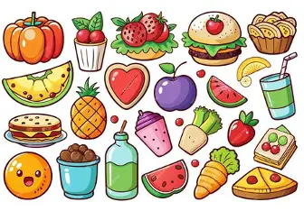

DUE DATE – 24 August 2026
RAFIQAH KIRBY - ST10438554

Table of Contents
Introduction 3
App 1 – Uber Eats 4
Overview 4
Strengths and Weaknesses: 4
How the app was implemented: 4
App 2 – Mr D 5
Overview 5
Strengths and weaknesses: 5
How the app was implemented: 5
App 3 – ezCater 6
Overview 6
Strengths and weaknesses 6
How the app was implemented: 6
Comparison of the Three Applications: 7
Features to Include in R&T Halaal Catering 7
Conclusion 8
References 9

Introduction
To boost client convenience, simplify ordering procedures, and improve business operations, the catering industry has embraced mobile applications more and more. Without having to get in touch with the company directly, mobile applications let users browse products, customize purchases, make safe payments, and get order updates. These apps are especially helpful for catering companies because they make managing big pre-orders, event reservations, and client correspondence easier.
Giving customers an easy-to-use platform to place catering orders for events including birthdays, weddings, business meetings, baby showers, graduations, funerals, and family get-togethers is the aim of the proposed application, R&T Halaal Catering. Unlike traditional food delivery apps that focus on single meals and instant delivery, this app will specialize in bulk pre-orders, catering packages, platters, sweet and savoury treats, catering pots, flexible payment options, and scheduled collection or delivery on the customer's event date.
To gain a better understanding of industry standards and best practices, three current Android apps with similar functionality have been evaluated. The purpose of this paper is to evaluate these applications through analysing their characteristics, advantages, disadvantages, and possible implementation strategies. The features and design ideas found in the research findings will be used in the development of the R&T Halaal Catering application.

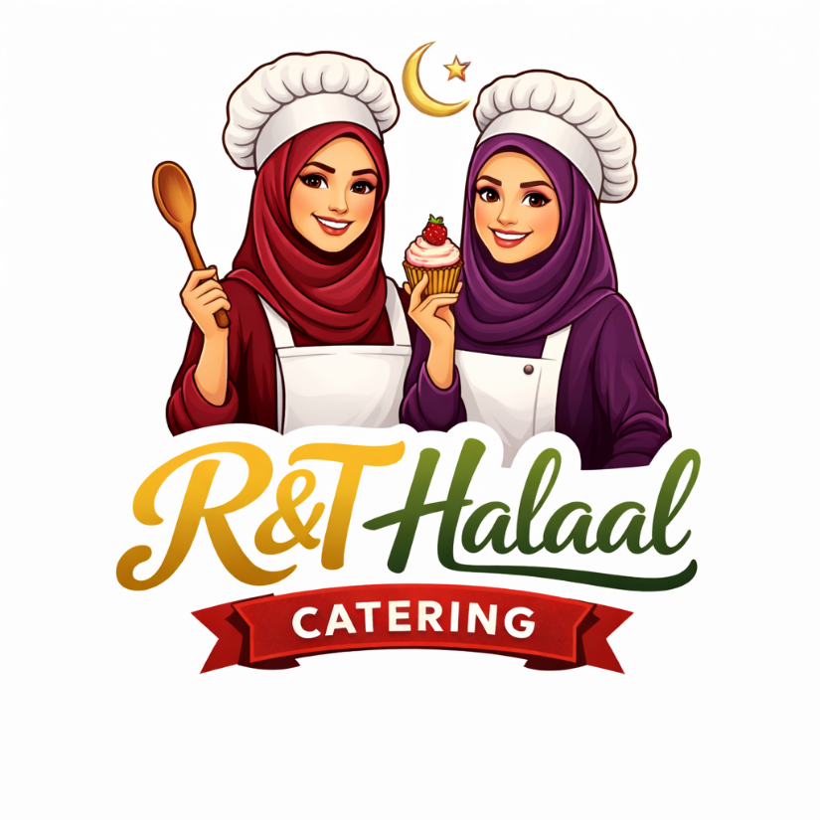

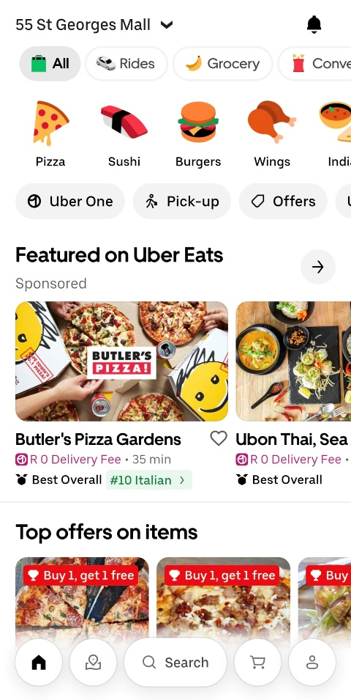
App 1 – Uber Eats

Overview
One of the most popular meal ordering apps in the world is Uber Eats, which is accessible on iOS and Android smartphones. Customers may use the app to browse restaurants, look up meals, personalize orders, make safe online payments, and monitor delivery in real time. It offers an easy-to-use interface that lets users find local food suppliers, bookmark their favourite eateries, and see past orders.
The application also offers customer accounts, delivery scheduling, digital payments, promotional offers, ratings, and reviews. Although Uber Eats focuses primarily on restaurant food delivery rather than catering, many of its core ordering and payment features are applicable to the proposed R&T Halaal Catering application.

Strengths and Weaknesses:
Strengths | Weaknesses
Easy-to-use interface | Designed mainly for immediate food delivery
Secure online payments | Limited support for event catering
Live order tracking | Not suitable for large bulk catering orders
Customer ratings and reviews | Limited customisation for large functions
Multiple payment methods | Not always reliable on time delivery

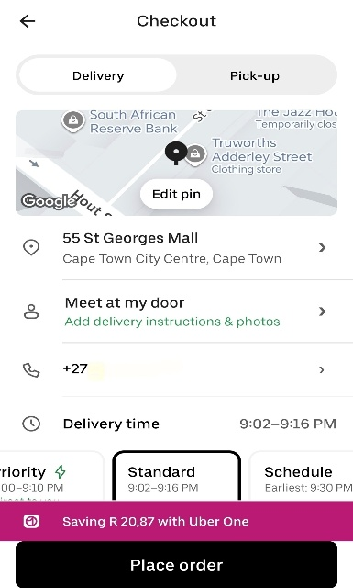
How the app was implemented:
Based on my knowledge and research I would likely believe that the uber eats app was implemented using the following:
- Android Studio
- Kotlin and Java
- RESTful APIs
- Firebase Authentication
- Cloud-based databases
- Google Maps API
- Payment gateway integration
The above applications would allow communication with remote servers, gather restaurant information, process payments and provide live order updates.

App 2 – Mr D

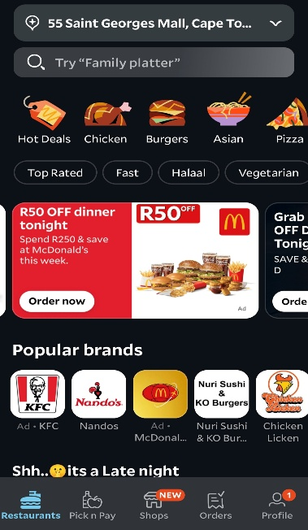
Overview
One of the most widely used apps for ordering meals in South Africa is Mr. D. Customers can use a single mobile application to place meal orders from restaurants and grocery stores. Menus, product searches, safe online payments, delivery scheduling, and real-time order tracking are all available to users.
The program provides an easy-to-use interface that facilitates navigating. Through the app, users may repurchase past purchases, save their favourite addresses, and get special offers. Many of Mr. D's features, especially its ordering procedure, payment options, and order administration, are applicable to the proposed R&T Halaal Catering application, even though the app focuses on on-demand delivery rather than catering.

Strengths and weaknesses:
Strengths | Weaknesses
Real - time tracking | Minimum quantity can be ordered
Saved order history | Not suitable for big events
Saved customer profiles | Delivery time isn’t always reliable
Multiple payment methods | Designed for immediate delivery
Simple interface that allows user to browse products.
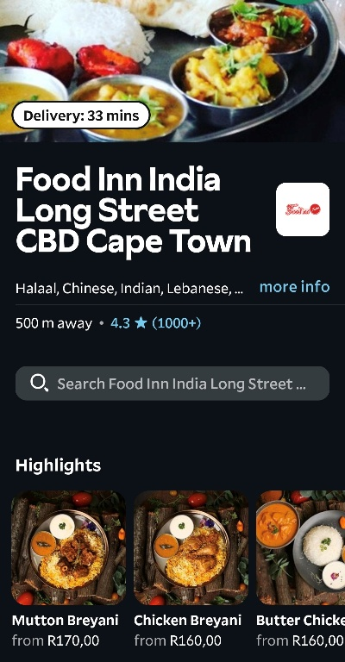

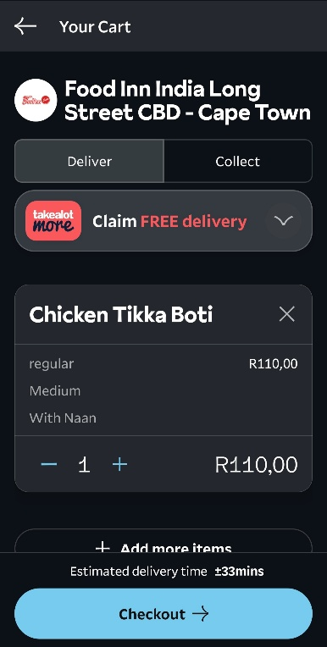
How the app was implemented:
Mr. D was developed using Android Studio with Kotlin and Java, according to the standards of Android programming. To get menus, customer data, pricing, and order details, the application uses RESTful APIs to interface with cloud servers. Payment gateways securely handle online transactions, while user accounts, orders, and product data are stored in a cloud database. Customers are kept up to date on the status of their orders through push notifications.

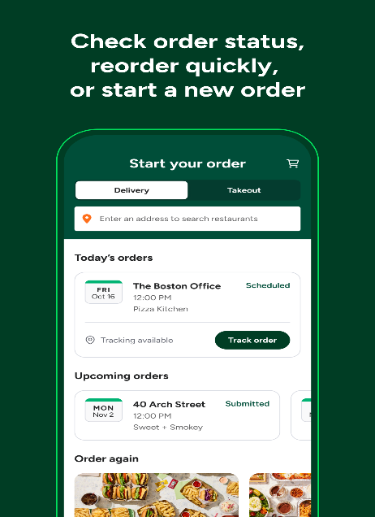
App 3 – ezCater

Overview
A smartphone software called ezCater was created especially for workplace events and catering requests. It concentrates on large catering orders that are prearranged, in contrast to typical meal delivery apps. In addition to managing recurring orders, scheduling delivery dates, placing orders for meetings or events, and receiving order confirmations and delivery updates, customers can peruse catering menus. The app lets customers reorder past catering orders, filter catering alternatives according to dietary preferences, and save their favourite restaurants.

Strengths and weaknesses
Strengths | Weaknesses
Advance ordering for events | Mainly caters for workplaces in the United States
Large orders for events | More suitable for corporate than personal events
Access to invoices | Connects customers with multiple caters
Delivery notification

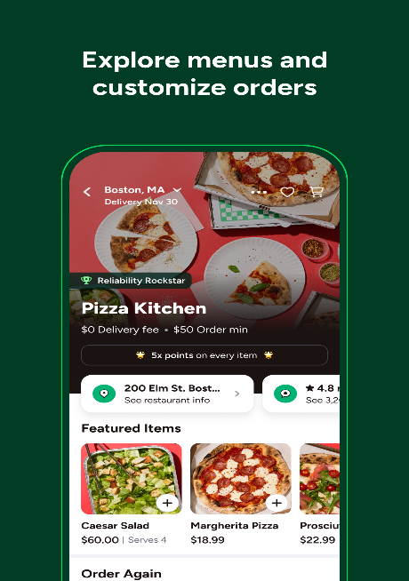
How the app was implemented:
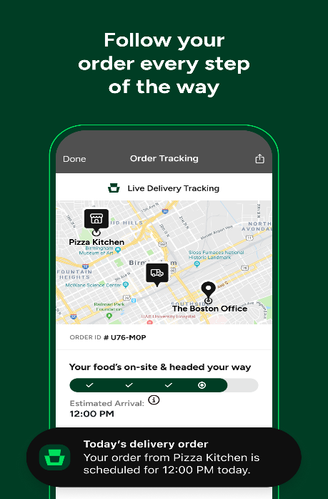
Android Studio and RESTful APIs that connect to cloud-hosted databases are probably used in the application. Cloud services maintain user accounts, catering menus, event dates, payment details, and order histories. Order confirmation and delivery information are sent via push notifications. The application seems to include cloud storage for menu graphics, login services, and payment processing.

Comparison of the Three Applications:
Uber Eats, Mr D, and ezCater all provide essential services like customer accounts, product browsing, shopping carts, payments, order tracking, and reviews. Uber Eats and Mr D mostly focus on individual food orders and delivery, whereas ezCater focuses on advance catering orders and events.
R&T Catering will combine the greatest characteristics of these apps with specialized catering functionality. The R&T Halaal Catering app will allow for bulk pre-orders, a minimum purchase of 20 items, sweet and savoury snacks, platters, large catering pots, catering packages, event scheduling, pickup or delivery, deposit or full payment, order monitoring, and customer evaluations. This makes the service better suited for large gatherings and functions than a traditional food delivery app.

Features to Include in R&T Halaal Catering:
After the research of the three applications, several characteristics that will improve the proposed R&T Halaal Catering application's design were discovered. The program will use Uber Eats' order history, secure payment method, customer reviews, shopping cart features, and clean user interface. For customers, these elements offer a seamless and comfortable experience.
According to Mr. D, the application will include customer profiles, several payment choices, promotional ads on the home screen, straightforward navigation, and a quick checkout procedure. These characteristics enhance usability and promote recurring business.
ezCater will incorporate features such planned pre-orders, catering menus, event date selection, large quantity ordering, delivery scheduling, and order management that are directly related to event catering. These characteristics closely align with R&T Halaal Catering's business strategy.
The suggested application will add a number of features that set it apart from other applications of a similar nature in addition to these current features. Consumers will be able to create their own platters, personalize catering menus, purchase huge catering pots of food, decide whether to pay the full cost or a deposit, get quotes automatically before confirming an order, and provide verified reviews when an order is finished. These features are especially made to satisfy the demands of a catering company that specializes in large-scale event orders as opposed to individual food purchases.

Conclusion
The purpose of this study was to look into existing Android apps that offer features similar to those meant for the R&T Halaal Catering application. Using Android Studio and modern mobile development tools, the functionality, advantages, disadvantages, and possible implementation of three applications were investigated.
According to the study, Mr. D and Uber Eats offer great illustrations of user-friendly interfaces, safe payment processing, customer accounts, order monitoring, and customer feedback. These apps show how a straightforward and effective ordering procedure can enhance the user experience in general. However, the specialized needs of catering firms that rely on large orders and advance bookings are not well supported by either program, which is primarily focused on instant meal delivery.
However, while ezCater focuses on planned catering orders for events, it offers functionality that is far more like the suggested R&T Halaal Catering program. Features like delivery planning, high quantity ordering, and event scheduling closely correspond with R&T Catering's business procedures. ezCater is primarily intended for corporate catering and lacks several features that would be advantageous to a small catering company, like personalized platters, a variety of cooking pots, deposit payment methods, and adaptable event packages.
The best aspects from all three apps will be combined in the planned R&T Halaal Catering application, which will also add features created especially for the catering sector. Sweet treats, savoury treats, platters, catering pots, and catering packages will all be available for customers to peruse. They can also customize their orders, choose an event date, pick between delivery and pickup, pay in full or with a deposit, monitor the status of their order, and leave verified reviews once it's finished.
The information presented in this report offers a solid basis for the project's planning and design stage. The results have assisted in identifying novel features and industry best practices that will support the creation of a useful, user-friendly, and effective mobile application that satisfies R&T Halaal Catering's operational requirements as well as consumer needs.

References
Android Developers. (2025). Android Developers Documentation. Available at: https://developer.android.com/ (Accessed: 5 August 2026).
Google Play. (2026). Uber Eats: Food Delivery. Available at: https://play.google.com/store/apps/details?id=com.ubercab.eats (Accessed: 10 August 2026).
Google Play. (2026). Mr D. Available at: https://play.google.com/store/apps/details?id=com.mrdelivery.mrd (Accessed: 10 August 2026).
Google Play. (2026). ezCater – Business Catering. Available at: https://play.google.com/store/apps/details?id=com.ezcater.ezcaterapp (Accessed: 10 August 2026).
Firebase. (2025). Firebase Documentation. Available at: https://firebase.google.com/docs (Accessed: 11 August 2026).

